

**MOBILE RECHARGE COMPANY**

*A*

*Major Project Report*

*Submitted*

*In partial fulfillment*

*For the award of the Degree of*

**BACHELOR OF TECHNOLOGY**

*In the Department of Computer science and Engineering*

**Submitted by:**

Tina Soni (18ETCCS092)

Mohammed Rauf (18ETCCS061)

Yasra Fatema (18ETCCS099)

***Department of Computer Science and Engineering***

***TECHNO INDIA NJR INSTITUTE OF TECHNOLOGY***

*RAJASTHAN TECHNICAL UNIVERSITY*

***May 2022***

***TECHNO INDIA NJR INSTITUTE OF TECHNOLOGY***



***CERTIFICATE***

This is to certify that this project report “**Mobile Recharge Company**” is the work of “**Tina Soni(18ETCCS092), Mohammed Rauf(18ETCCS061), Yasra Fatema(18ETCCS099)**” who have carried out the project work under my supervision. I approve this project for submission of the Bachelor of Technology in the **Department of Computer Science and Engineering, Techno India NJR Institute of Technology**, affiliated to Rajasthan Technical University, Kota.

**Mr. Aditya Maheshwari**

**Project In-charge**

**Department of Computer Science**

***ABSTRACT***

***1. Purpose***

***1.1. Introduction***

MIO is basically a mobile service company.A popular mobile company wanted to launch a fellow enterprise. They needed a new application to serve their customers and to maintain their products and sales. We, with the help of salesforce resolved the requirement by creating customs objects and creating profiles necessary to meet the need. As a result of this revenue will be increased for MIO.

***1.2. Scope***

The basic goal is to create a B2C application comprising of prepaid data plans for mobile and fibre recharge wherein the employees can maintain records of the products purchased by the customers. We will be using basic salesforce credentials to meet this requirement.​

***2. Document overview***

The remainder of this document is 8 chapters, the first providing an introduction to the project. It lists all the functions performed by the system. The second chapter consists of software requirements specification. The third chapter provides details about system analysis and design. The fourth chapter gives data dictionary information. The fifth chapter consists of snapshots of the complete project. The sixth chapter gives testing for the project. The seventh chapter tells about the conclusion and future enhancements of the project. The final chapter concerns the bibliography.

***ACKNOWLEDGEMENT***

It gives me immense pleasure to express my deepest sense of gratitude and sincere thanks to my highly respected and esteemed guide **Mr. Aditya Maheshwari (Project In-charge), TINJRIT** for their valuable guidance, encouragement, and help in completing this work. Their useful suggestions for this whole work and cooperative behavior are sincerely acknowledged. At the end, I would like to express my sincere thanks to all my friends and others who helped me directly or indirectly during this project work.

I also wish to express my indebtedness to my parents as well as my family members whose blessings and support always helped me to face the challenges ahead.

At the end I would like to express my sincere thanks to all my friends and others who helped me directly or indirectly during this project work.

Tina Soni (18ETCCS092)

Mohammed Rauf (18ETCCS092)

Yasra Fatema (18ETCCS092)

*Udaipur, Rajasthan - 313001*

*28/05/2022*

***TABLE OF CONTENTS***

***Table of Contents***

*Abstract....................................................................................................................................... 3*

*Acknowledgment.........................................................................................................................5*

*Table of Contents ...................................................................................................................... 6*

*List of Symbols........................................................................................................................... 8*

***CHAPTER – 1 Introduction****......................................................................................................9-12*

*Introduction ............................................................................................................................... 10*

*1.1.Purpose................................................................................................................................10*

*1.2.Overall Description ..............................................................................................................12*

***CHAPTER – 2 Software Requirement Specification*** *........................................................... 15-18*

*2.1. Purpose.............................................................................................................................. 15*

*2.2. Glossary.................................................................................................................……......17*

*2.2.1. References…………………………... ...............................................................................18*

***CHAPTER – 3 System Analysis and Design*** *....................................................................... 19- 22*

*3.1. Study & Weaknesses of current system .............................................................................19*

*3.2 Requirements of new system .............................................................................................. 21*

*3.3. Feasibility Study ................................................................................................................. 21*

*3.4. Features of new System ..................................................................................................... 22*

***CHAPTER – 4 Data Dictionary*** *................................................................................................24-28*

*4.1. Data Elements ......................................................................................................................25*

*4.2. Data Structure .......................................................................................................................25*

*4.3 Table ………………………………………………………………………………………………… 26*

*4.4 E-R Diagram ………………………………………………………………………………………. 27-28*

***CHAPTER - 5 ScreenShots*** *..................................................................................................... 29-40*

*5.1. Dashboard.......................................................................................................................... 30*

*5.2. Modules .............................................................................................................................. 33*

*5.3. Registration. ........................................................................................................................34*

*5.4. Test………….......................................................................................................................36*

*5.5. LogOut ….. ........................................................................................................................ 40*

***CHAPTER – 6 Testing*** *.............................................................................................................41-49*

*6.1. Testing Methodology........................................................................................................... 42*

*6.2. System Testing……............................................................................................................ 43*

*6.3. Program Testing.........................................................................................................……. 44*

*6.4. String Testing..................................................................................................................... 45*

*6.5. System Testing …………………………………………………………………………………..46*

*6.6. System Documentation..................................................................................................... 46*

***CHAPTER – 7 Conclusion and Future Enhancements*** *...................................................... 50- 52*

*7.1. Limitations .......................................................................................................................... 51*

*7.2. Future Enhancements ........................................................................................................ 51*

*7.3. Conclusion ......................................................................................................................... 51*

***CHAPTER – 8 Bibliography*** *.................................................................................................... 52-53*

***List of Symbols***

|  |  |
| --- | --- |
| Term | Definition |
| Customer | The user who login to the site for purchasing the product. |
| Admin | Admin keeps all the track of the employee and customer and can add new products and offers |
| Employee | Employee keeps the track of the customer and track revenue generated |
| QA | Quality assurance |
| SCMP | Software Configuration Management Plan |
| SDD | Software Design Document |
| SFDC | **Salesforce.com** |
| SRS | Software Requirements Specification |
|  |  |

***CHAPTER – I***

***INTRODUCTION***

Introduction

***1. Purpose***

***1.1.1 Introduction***

MIO is basically a mobile service company.A popular mobile company wanted to launch a fellow enterprise. They needed a new application to serve their customers and to maintain their products and sales. We, with the help of salesforce resolved the requirement by creating customs objects and creating profiles necessary to meet the need. As a result of this revenue will be increased for MIO.

***1.1.2 Scope***

The basic goal is to create a B2C application comprising of prepaid data plans for mobile and fibre recharge wherein the employees can maintain records of the products purchased by the customers. We will be using basic salesforce credentials to meet this requirement.​

***1.1.3. References***

*SFDC Documents*

*Youtube*

***1.1.4. Document overview***

The remainder of this document is 8 chapters, the first providing an introduction to the project. It lists all the functions performed by the system. The second chapter consists of software requirements specification. The third chapter provides details about system analysis and design. The fourth chapter gives data dictionary information. The fifth chapter consists of snapshots of the complete project. The sixth chapter gives testing for the project. The seventh chapter tells about the conclusion and future enhancements of the project. The final chapter concerns the bibliography.

This document is meant for describing all the features and procedures that were followed while developing the system. This document specially mentions the details of the project, how it was developed, the primary requirement, as well as various features and functionalities of the project, and the procedures followed in achieving these objectives.

This Salesforce Application forms the lifeline of the Telecom companies to the functioning of the Test and Modules. It is very essential for an organization to handle the users and their data. It is very useful for an organization to provide extra services to its users continuously for their development. This system is helpful for the telecom company to showcase their different plans and offer on different level rather than going to the shops and getting recharge done customer can do the recharge according to their need and can avail the discount.

The IT initiatives have encouraged various Organizations to develop systems to facilitate their day to day operations. The Mobile recharge Application will include various offers for their customer and is very easy to use. This system helps in providing purchasing quickly and can thus help in saving time and the operations will be carried out efficiently.

##### ***1.2 Overall description***

Mobile recharge Application is designed for Telecom Organizations .The system handles all the operations and generates provide all the necessary plans which customer can choose and many offers customer can avail during their purchase of and plans.

###### **1.2.1. Functional requirements definitions**

Functional Requirements are those that refer to the functionality of the system, i.e., what services it will provide to the user. Nonfunctional (supplementary) requirements pertain to other information needed to produce the correct system and are detailed separately.

###### **1.1.1. Use cases**

This system will be used in Five User Modules, YouTube Links, and Tests. As all of these have different requirements the modules are designed to meet their needs and avoid any type of confusion. The Uses of the application are described below.

[1] User can do the following functions:-

* Fill enquiry form
* Register(Add Details)
* Login to the account
* Choose their plans
* Make Payment
* LogOut

[2] User can do the following functions in the Employee Module:

* Track customers
* Track revenue

[3] User Can do the following in Registration:

* Edit User Details
* Provide Pictures
* Check Status

***1.1.2. User characteristics***

The user should be familiar with English Language. The user should be familiar with the e-commerce websites.

#### ***1.1.3. Constraints***

Real-life credit card validation and Banking system is not implemented. No multilingual support(Only English).

***CHAPTER – II***

***Software Requirement Specification***

### **Software Requirement Specification**

**2.1.** **Purpose**

***2.1.1. Introduction***

MIO is basically a mobile service company.A popular mobile company wanted to launch a fellow enterprise. They needed a new application to serve their customers and to maintain their products and sales. We, with the help of salesforce resolved the requirement by creating customs objects and creating profiles necessary to meet the need. As a result of this revenue will be increased for MIO.

###### **2.1.2. Scope**

The basic goal is to create a B2C application comprising of prepaid data plans for mobile and fibre recharge wherein the employees can maintain records of the products purchased by the customers. We will be using basic salesforce credentials to meet this requirement.​

###### Scope of this project is very broad in terms of other manually Applications. Few of them are:-

* This can be used in organizations as well as in the corporate world.
* Can be used anywhere any time as it is a mobile based application.
* No restriction that anyone has to be present when the customer purchase the product.
* Users should know only Hindi, no requirement of English or other languages.

***2.1.3 Glossary***

Table 2.1

|  |  |
| --- | --- |
| **Term** | **Definition** |
| Customer | The user who login to the site for purchasing the product. |
| Admin | Admin keeps all the track of the employee and customer and can add new products and offers |
| Employee | Employee keeps the track of the customer and track revenue generated |

|  |  |
| --- | --- |
| QA | Quality assurance |
| SCMP | Software Configuration Management Plan |
| SDD | Software Design Document |
| SFDC | **Salesforce.com** |
| SRS | Software Requirements Specification |

**2.1.2.** **References**

SFDC Documents

Youtube

***CHAPTER – III***

***System Analysis and Design***

### 

### ***System Analysis and Design***

### ***3.1. Study & Weaknesses of Current System***

The Current system of application is highly complicated and expensive. Whenever purchase to be done there are various tasks that have to be done again and again.

* Setting products
* Checking availability of products
* Applying offers
* Making payments

##### **Weaknesses in Current System**

The current system is as mentioned earlier very complicated and expensive as compared to the new system.

There is too much human interaction in this project like filling the enquiry form then employee will convert the user into authorized user then only customer will be able to login into the customer portal and can access the offers. As all these are done by the humans the chances of getting errors increases

Thus, the current system is in every way ineffective for making recharge in these days when time is more costly than anything and they also pose a threat to the environment when we are amidst a global crisis and in the need of a Green Revolution.

##### ***3.2. Requirements of New System***

***3.2.1.******User Requirements***

The User requirements for the new system are to make the system fast, flexible, less prone to errors and reduce expenses and save time.

· A system that can automate on converting the user into authorized user

· Product can be shown even before login into the customer portal

· If customer do not find any product according to their need they should not login into the customer portal

· Finally, it should prove cost effective as compared to the current system.

##### ***3.3. Feasibility Study***

A key part of the preliminary investigation that reviews anticipated costs and benefits and recommends a course of action based on operational, technical, economic, and time factors. The purpose of the study is to determine if the system's request should proceed further.

##### **3.4.** **Features of the New System.**

The new system has been designed as per the user requirements so as to fulfill almost all them.

**Adding Payment methods**

Payment methods like card payment is added into the system to make it more familiar with the customers. They can fill their credentials like card number, card holder name, expiry date and cvv to make the purchase of the product easily.

**Cost Effective**

One of the main reasons for the new system is its cost effectiveness. It saves the amount spent recharge vouchers.

***CHAPTER – IV***

***DATA DICTIONARY***

**DATA DICTIONARY**

A data dictionary is a catalog-a-repository of the elements in a system. As the name suggests, their elements center on data and the way they are structured to meet user requirements and organization needs. In a data dictionary, you will find a list of all the elements composing the data flowing through a system. The major elements are data flows, data stores, and processes. The data dictionary stores details and descriptions of these elements.

If analysis wants to know characters are in a data item by what other names it is referenced in the system, where it is referenced in the system, or where it is issued in the system, they should be able to find the answers in issued in the system, they should be able to find the answer in the properly developed data dictionary.

The Dictionary contains two types of descriptions for the data following through the system.

**1. Data Elements**

The most fundamental data is the elements. They are building blocks for all other data in the system. Data elements are also alternatively known as fields, data items or elementary items.

**2. Data Structure**

A data structure is a set of items that are related to one another and describe components in the system.

**3.Table Details**

|  |  |  |  |  |
| --- | --- | --- | --- | --- |
| **Field Name** | **Description** | **Constraints** | **Size** | **Data Type** |
| Username | Name of the user |  | 50 | Text |
| Mobile Number | Act as password |  | 50 | Number |

**4. E-R Diagram**

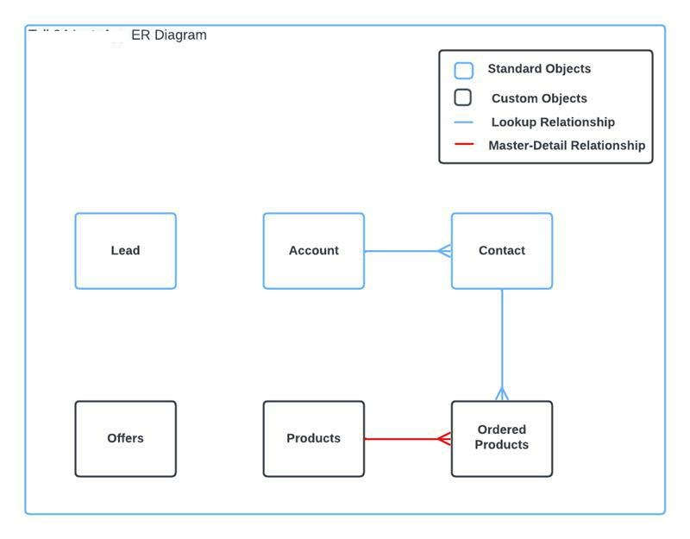

***CHAPTER – V***

***SCREEN SHOTS***

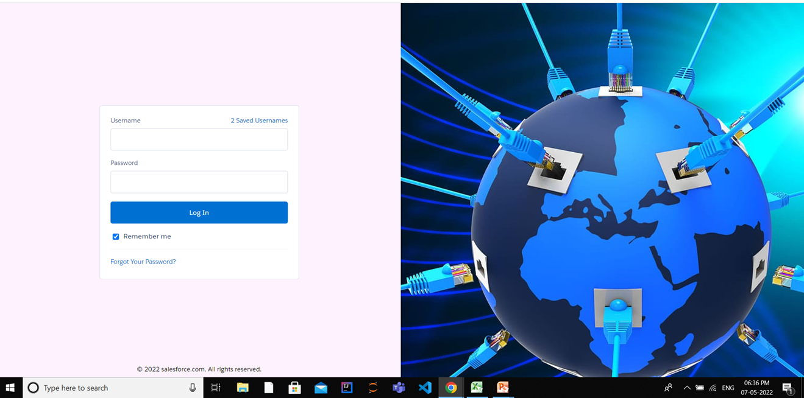

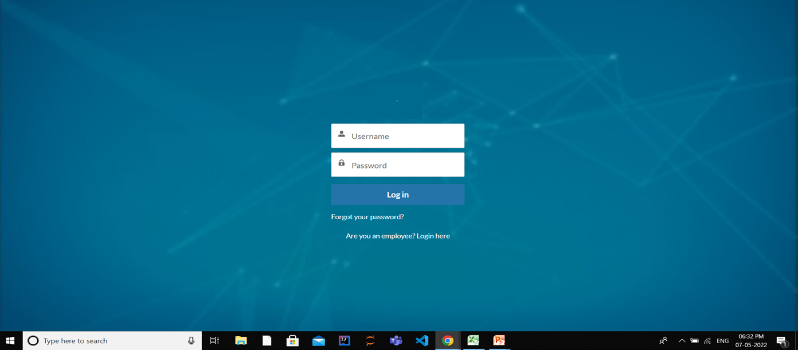

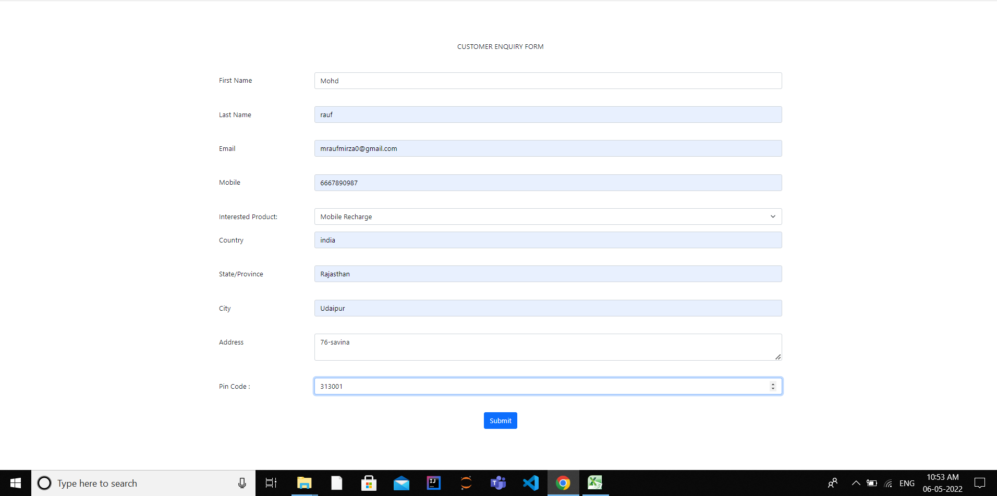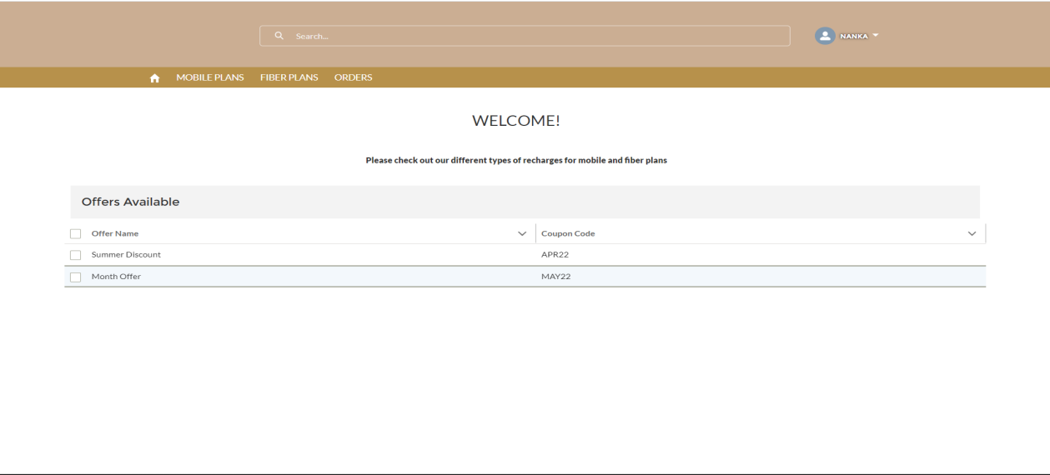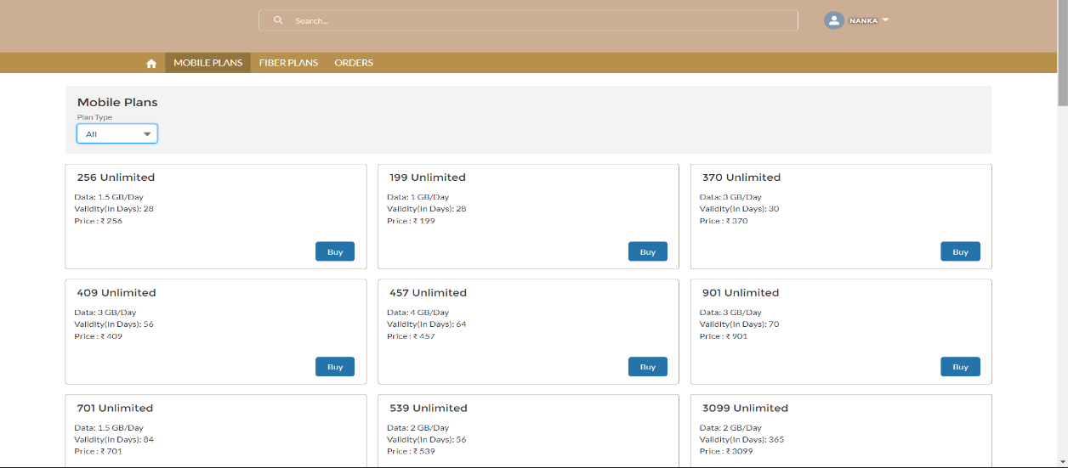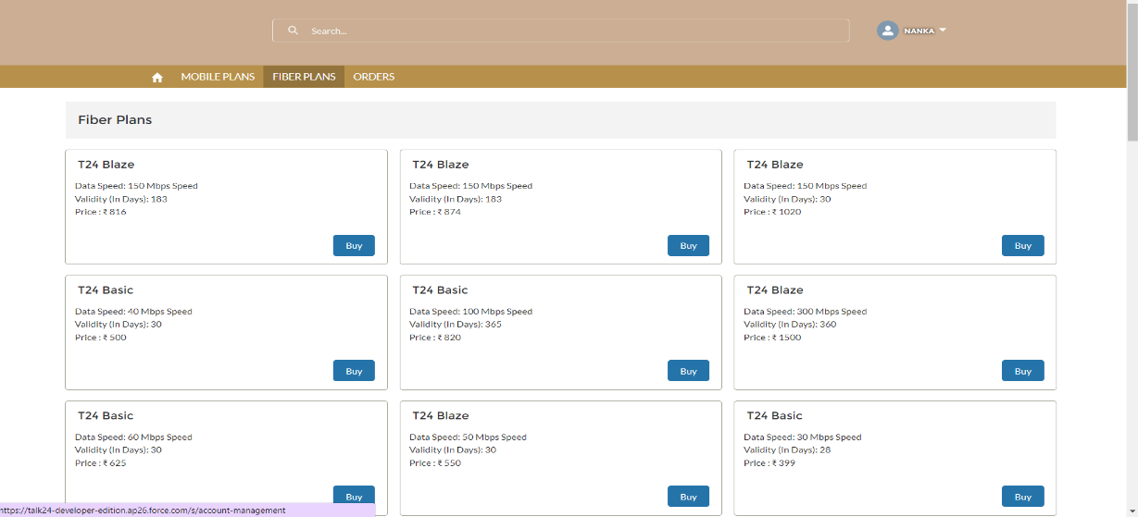

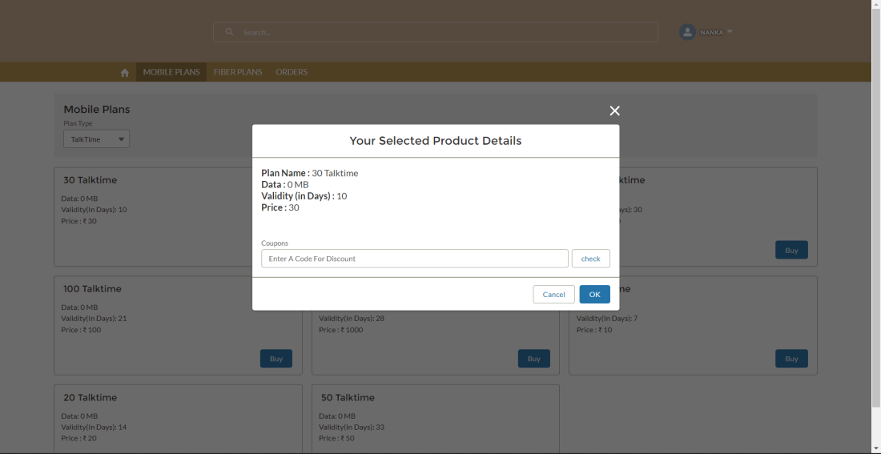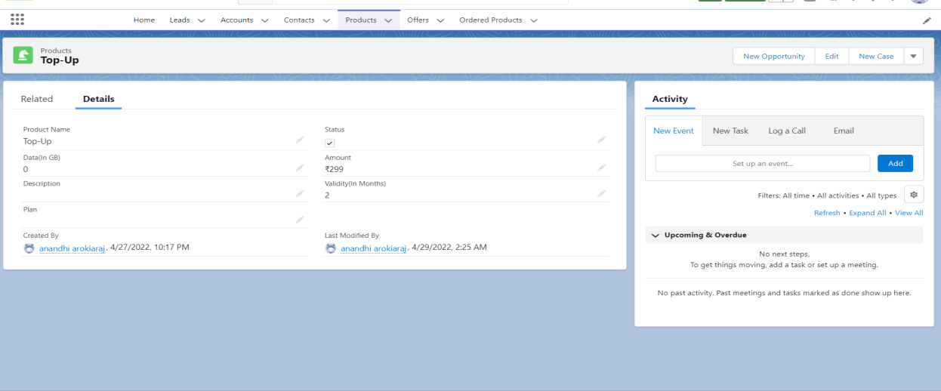

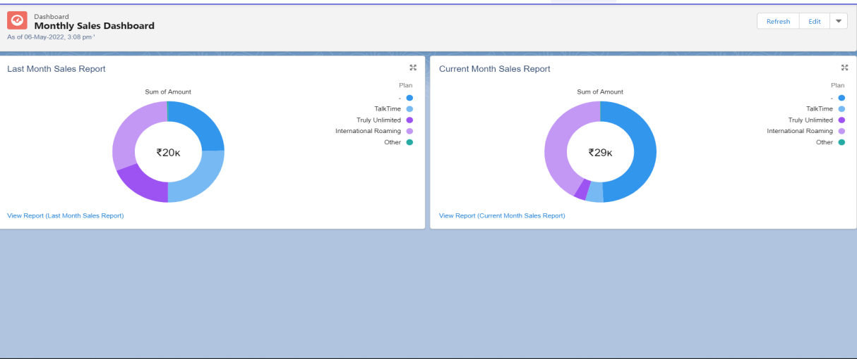

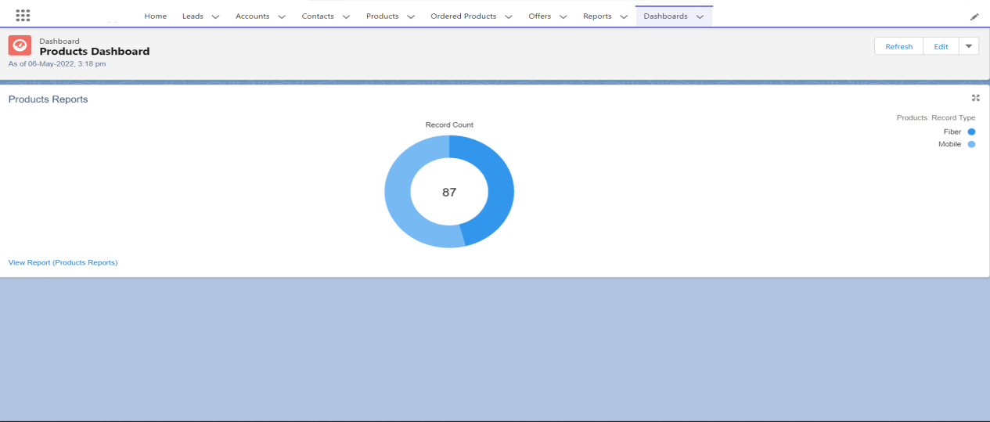

***CHAPTER – VI***

***TESTING***

***Testing***

**Testing Methodology**

Companies rely on software more than ever to provide and manage information with strategic and operational importance and to provide key decision support. Rising customer expectations for fault-free, requirements-exact software have increased awareness of the importance of software testing as a critical activity.

We begin the testing process by developing a comprehensive plan to test the general functionality and special features on a variety of platform combinations. Strict quality control procedures are used. The process verifies that the application meets the requirements specified in the system requirements document and is bug free. At the end of each testing day, we prepare a summary of completed and failed tests. Applications are not allowed to launch until all identified problems are fixed. A report is prepared at the end of testing to show exactly what was tested and to list the final outcomes.

Our software testing methodology is applied in three distinct phases: unit testing, system testing, and acceptance were testing.

**Unit Testing**: The programmers conduct unit testing during the development phase. Programmers can test their specific functionality individually or with other units. However, unit testing is designed to test small pieces of functionality rather than the system as a whole. This allows the programmers to conduct the first round of testing to eliminate bugs before they reach the testing staff. In unit testing the analyst tests the programs making up a system. For this reason, unit testing is sometimes called program testing. Unit testing gives stress on the

modules independently of one another, to find errors. This helps the tester in detecting errors in coding and logic that are contained within that module alone. The errors resulting from the interaction between modules are initially avoided.

For example, a hotel information system consists of modules to handle reservations; guest checking and checkout; restaurant, room service and miscellaneous charges; convention activities; and accounts receivable billing. For each, it provides the ability to enter, modify or retrieve data and respond to different types of inquiries or print reports. The test cases needed for unit-testing should exercise each condition and option. Unit testing can be performed from the bottom up, starting with smallest and lowest-level

modules and proceeding one at a time. For each module in bottom-up testing a short program is used to execute the module and provides the needed data, so that the module is asked to perform the way it will when embedded within the larger system.

**System Testing*:*** The objective of system testing is to ensure that all individual programs are working as expected, that the programs link together to meet the requirements specified and to ensure that the computer system and the associated clerical and other procedures work together. The initial phase of system testing is the responsibility of the analyst who determines what conditions are to be tested, generates test data, produces a schedule of expected results, runs the tests and compares the computer produced results with the expected results with the expected results. The analyst may also be involved in procedures testing. When the analyst is satisfied that the system is working properly, he hands it over to the users for testing. The importance of system testing by the user must be stressed. Ultimately it is the user must verify the system and give the go-ahead. During testing, the system is used experimentally to ensure that the software does not fail, i.e., that it will run according to its specifications and in the way users expect it to. Special test data is input for processing (test plan) and the results are examined to locate unexpected results. A limited number of users may also be allowed to use the system so analysts can see whether they try to use it in unexpected ways. It is preferable to find these surprises before the organization implements the system and depends on it. In many organizations, testing is performed by persons other than those who write the original programs.

Using persons who do not know how certain parts were designed or programmed ensures more complete and unbiased testing and more reliable software.

The system is tested as a complete, integrated system. System testing first occurs in the development environment but eventually is conducted in the production environment. Functionality and performance testing are designed to catch bugs in the system, unexpected results, or other ways in which the system does not meet the stated requirements. The testers create detailed scenarios to test the strength and limits of the system, trying to break it if possible. Editorial reviews not only correct typographical and grammatical errors but also improve the system’s overall usability by ensuring that on-screen language is clear and helpful to users. Accessibility reviews ensure that the system is accessible to users with disabilities.

System testing consists of the following five steps:

i. Program testing

ii. String testing

iii. System testing

iv. System documentation

v. User acceptance testing

***Program Testing***

A program represents the logical elements of a system. For a program to run satisfactorily, it must compile and test data correctly and tie in properly with other programs. It is the responsibility of a programmer to have an error free program. At The time of testing the system, there exist two types of errors that should be checked. These errors are syntax and logic. A syntax error is a program statement that violates one or more rules of the language in which it is written. An improperly defined field dimension or omitted key words are common syntax errors.

These errors are shown through error messages generated by the computer. A logic error, on the other hand, deals with incorrect data fields out of range items, and invalid combinations. Since the logical errors are not detected by the compiler, the programmer must examine the output carefully to detect them. When a program is tested, the actual output is compared with the expected output. When there is a discrepancy, the sequence of the instructions must be traced to determine the problem. The process is facilitated by breaking the program down into self-contained portions, each of which can be checked at certain key points.

***String Testing***

Programs are invariably related to one another and interact in a total system. Each program is tested to see whether it conforms to related programs in the system. Each part of the system is tested against the entire module with both test and live data before the whole system is ready to be tested.

***System Testing***

System testing is designed to uncover weaknesses that were not found in earlier tests. This includes forced system failure and validation of total system as it will be implemented by its user in the operational environment. Under this testing, generally we Take low volumes of transactions based on live data. This volume is increased until the maximum level for each transaction type is reached. The total system is also tested for recovery and fallback after various major failures to ensure that no data are lost during the emergency. All this is done with the old system still in operation. When we see that the proposed system is successful in the test, the old system is discontinued.

***System Documentation***

All design and test documentation should be well prepared and kept in the library for future reference. The library is the central location for maintenance of the new system.

***User Acceptance Testing***

An acceptance test has the objective of selling the user on the validity and reliability of the system. It verifies that the system's procedures operate to system specifications and that the integrity of important data is maintained. Performance of an acceptance test is actually the user's show. User motivation is very important for the successful performance of the system. After that, a comprehensive test report is prepared. This report shows the system's tolerance, performance range, error rate and accuracy.

**Table 6.1 Test Report with test data**

**TEST REPORT WITH TEST DATA**

(To be filled by System Analyst/Programmer)

**Project Name: Mobile Recharge company**

|  |  |  |
| --- | --- | --- |
| A. | INTERFACE TESTING  1) User-friendliness  2) Consistent menus | OK  NA |
| B. | CONTROL FLOW TESTING  1) IF-THEN-ELSE  2) DO WHILE  3) CASE-SWITCH | OK  OK  OK |
| C. | VALIDATION TESTING  1) Check for improper or inconsistent typing  2) Check for erroneous initialization or default values  3) Check for incorrect variable names  4) Check for inconsistent Data Types  5) Check for relational/arithmetic operators | OK  OK  OK  OK  OK |
| D. | DATA INTEGRITY/SECURITY TESTING  1) Data Insertion/ Deletion/ Updating  2) Boundary condition (Underflow, Overflow Exception)  3) Check for unauthorized access of data  4) Check for data availability | OK  OK  OK  OK |
| E. | EFFICIENCY TESTING  1) Throughput of the system  2) Response time of the system  3) Online disk storage required by the system  4) Primary memory required by the system | OK  OK  OK  OK |
| F. | ERROR HANDLING ROUTINES  1) Error description are intelligent/ understandable  2) Error recovery is smooth  3) All error handling routines are tested and executed at least once | OK  OK  OK |

***CHAPTER – VII***

***CONCLUSION AND FUTURE ENHANCEMENTS***

**7.1 Limitations:**

The new system has been designed to meet almost all of the user requirements but it too has certain limitations some of which can be enhanced in the future enhancements or updates

**7.2 Future enhancements:**

1. API Integration

2. We can introduce new plans, DTH, Landline.

3. Website Publishing

4. Introducing more Validations

5. Person Account

**7.2.1 Availability on Different Platforms :**

The new system will be available on different platforms such Mac, ios, Linux, etc.

**7.3 Conclusion:**

It is a salesforce based application developed to make a user friendly an interactive and customer friendly application which will attract the customer and to generate more revenue**.**

***CHAPTER – VIII***

***BIBLIOGRAPHY***

Glossary

* **Assumptions and Dependencies**-

Describes any assumptions that may be wrong or any dependencies on other things.

* **Goals and Guidelines** -

Describes any goals and guidelines for the design of the software.

* **Architectural Strategies**-

Describe the strategies that will be used while designing the software

**References and Bibliography:**

* Salesforce Docs - https://developer.salesforce.com/docs/
* Youtube